Procedure 1: Manual Process.

Step- 1 : Login into your AWS console and Create an instance with Ubuntu machine with instance type t2.medium.

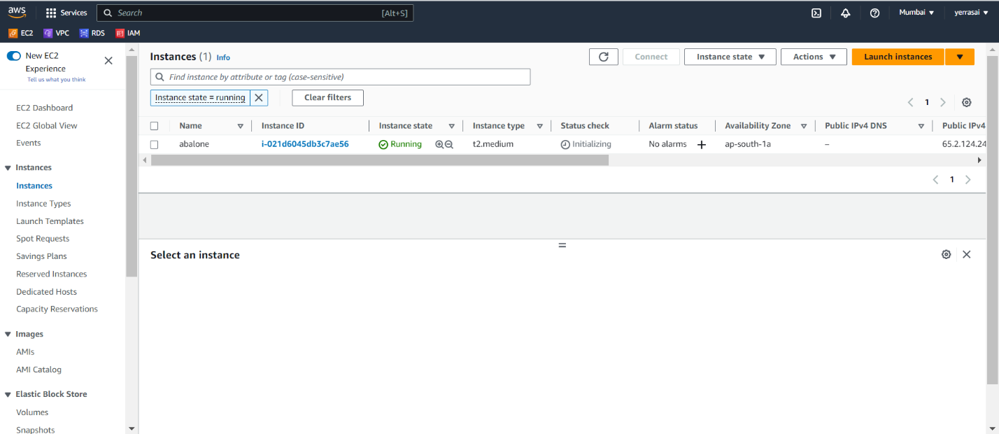

* Step 2 : Now open terminal and connect to the instance through SSH – key.

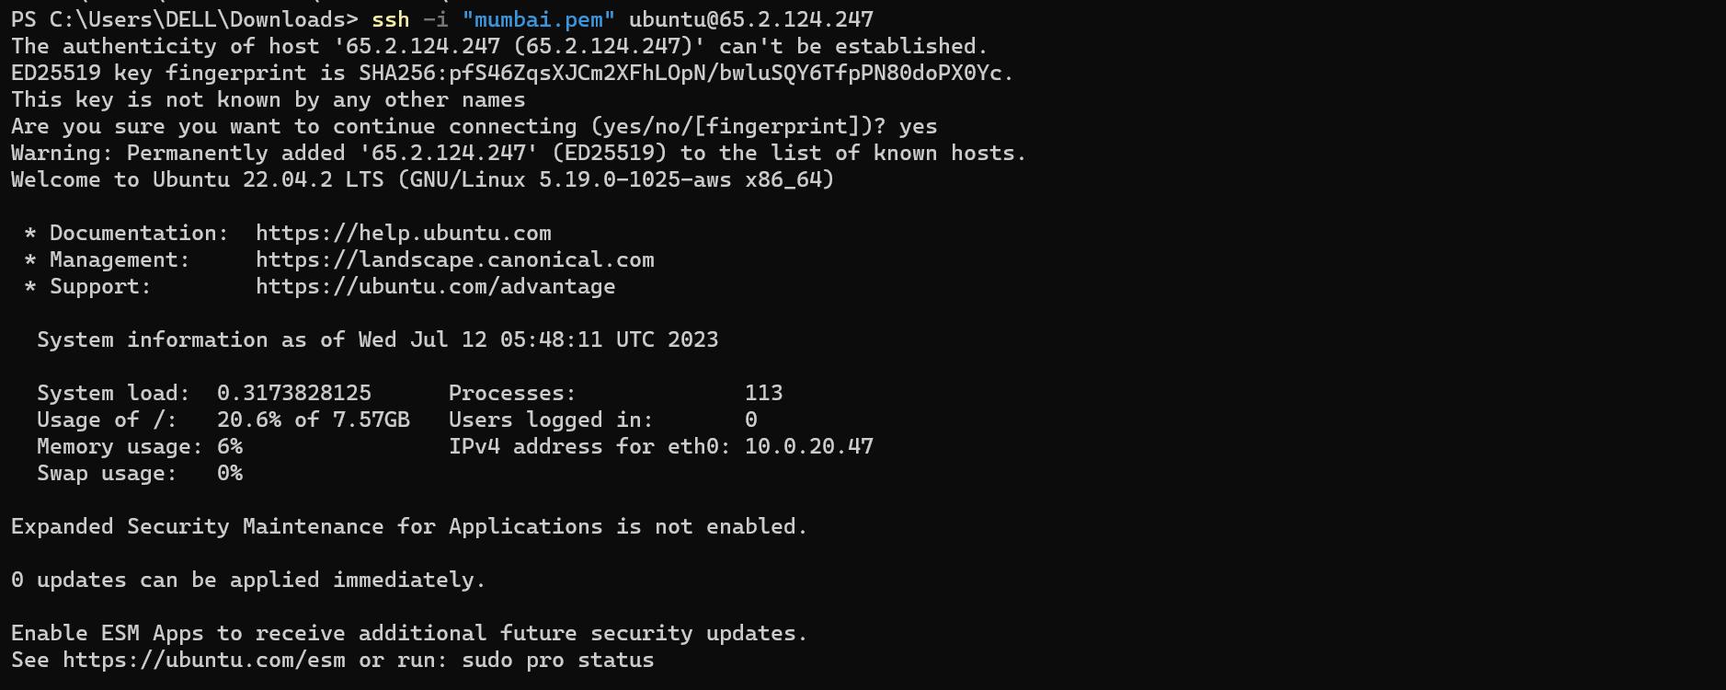

* Step 3 : Now update the machine by using the command
* Sudo apt update -y

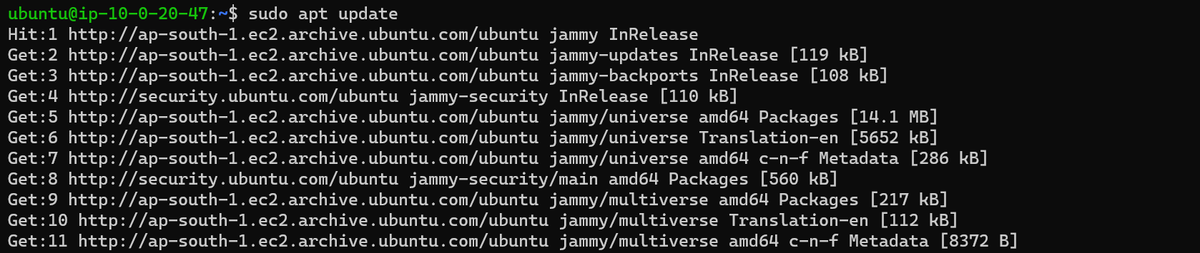

Step 4 : Now install python3 .

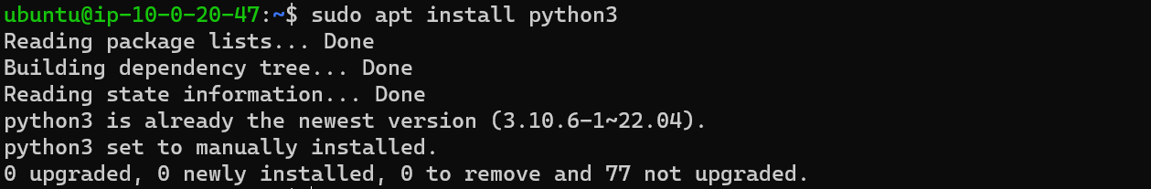

Step 5 : Now clone git repository and go to that file.

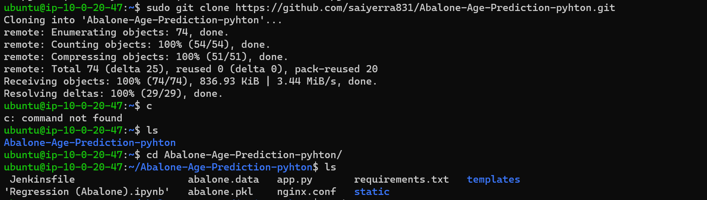

Step 6 : After cloning to that repo edit the file of app.py

* Sudo vi app.py

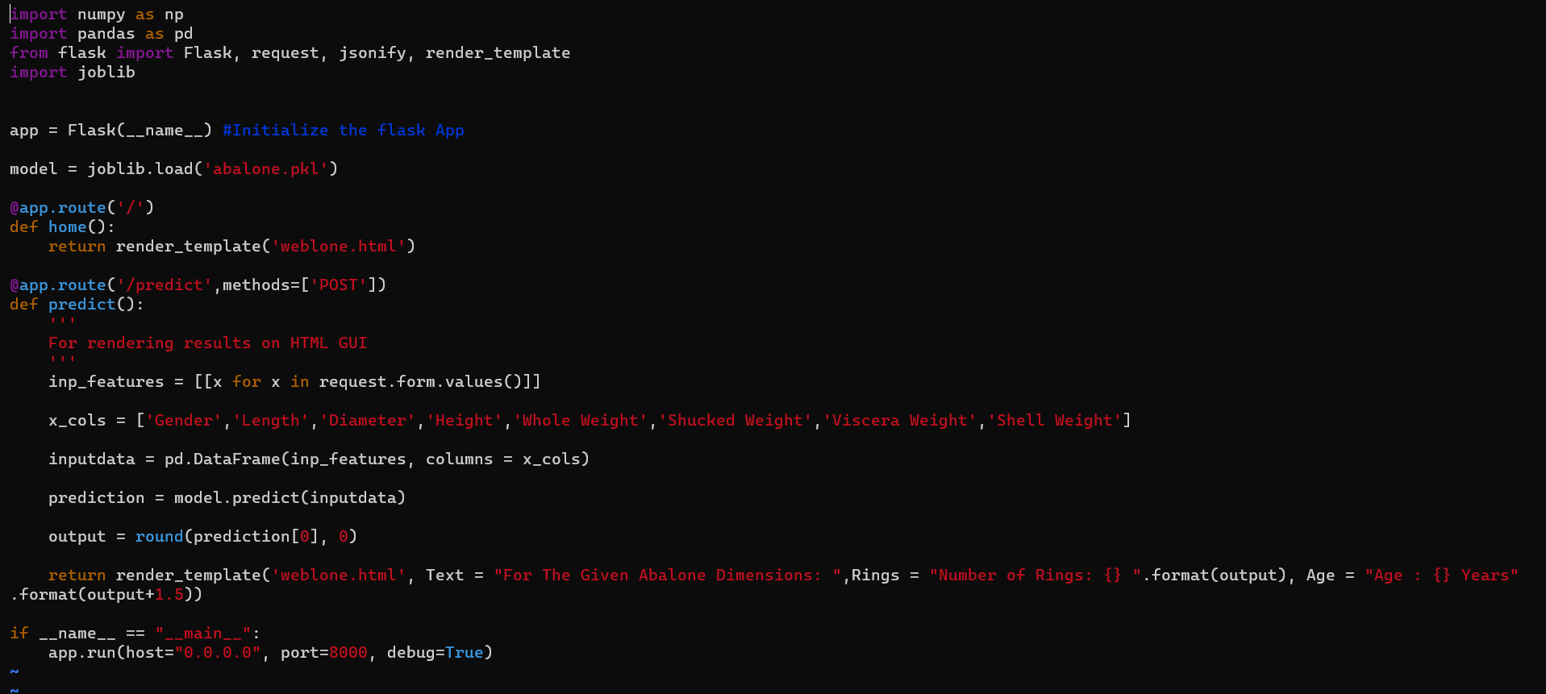

Step 7 : pip3 install -r requirements.txt. 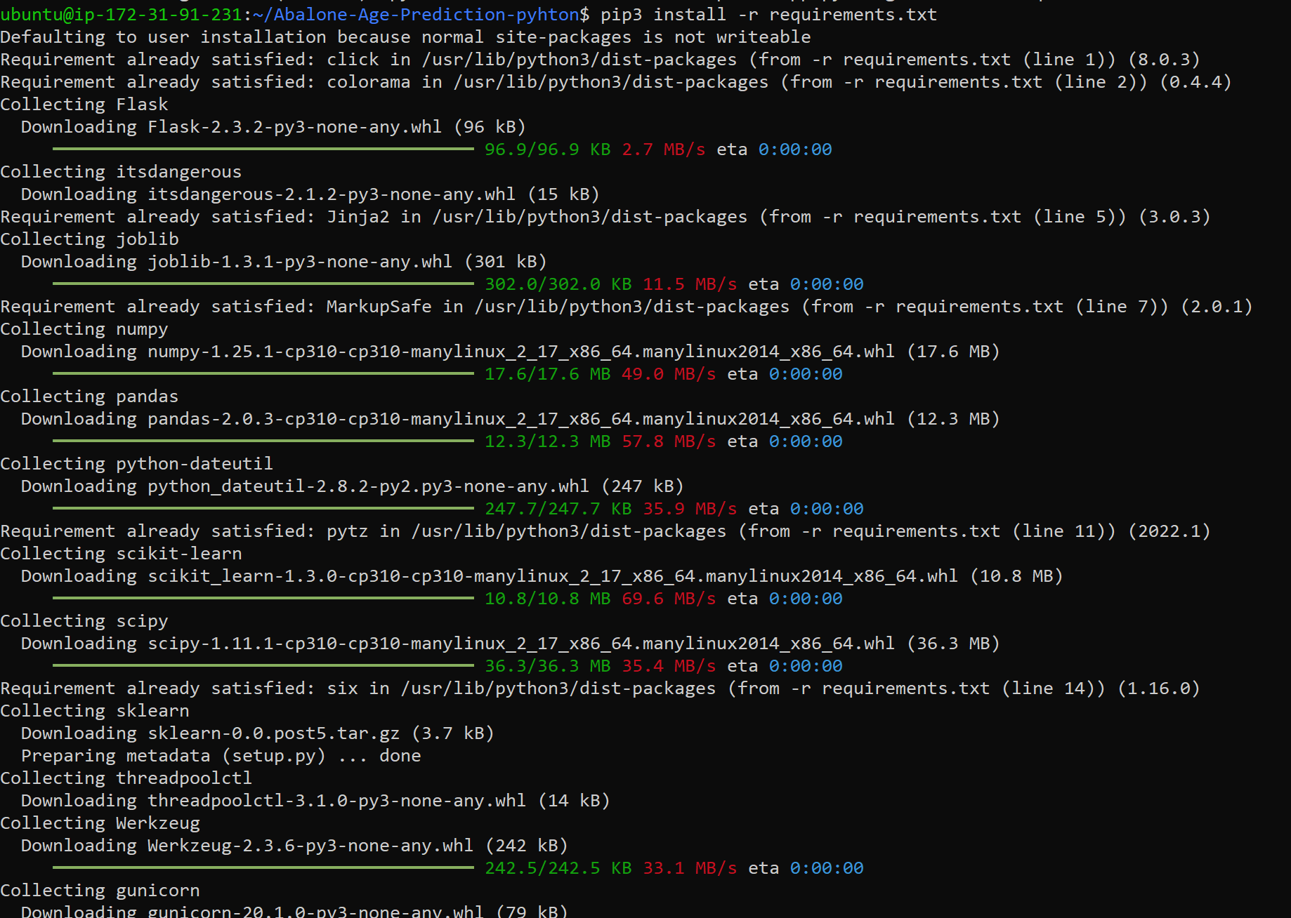

* Now again run python3 app.py

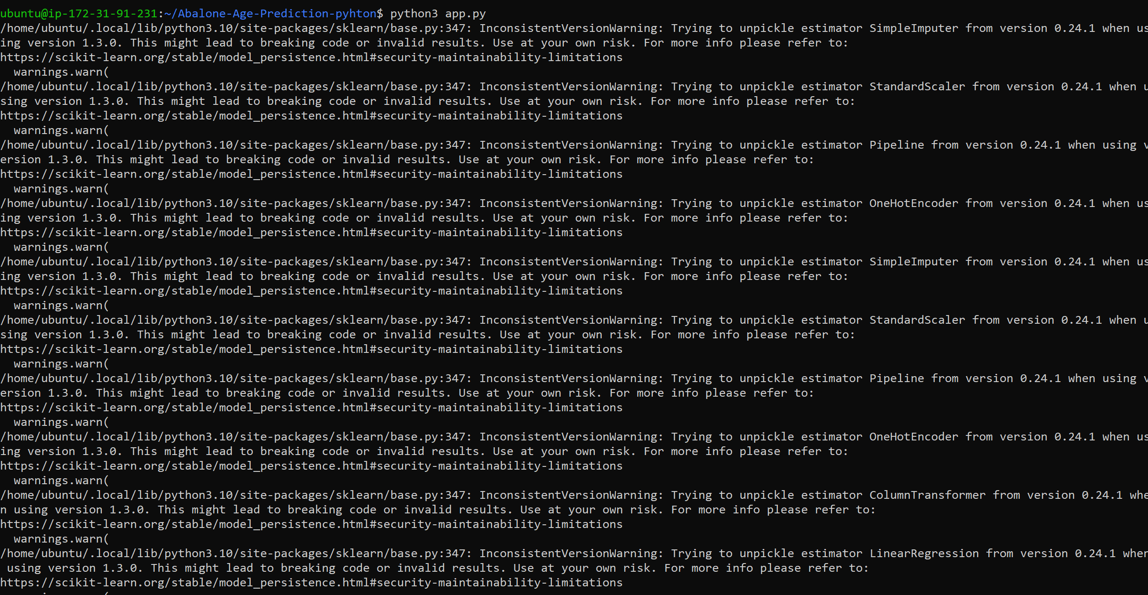

* Now go to AWS console and copy the public ip address.

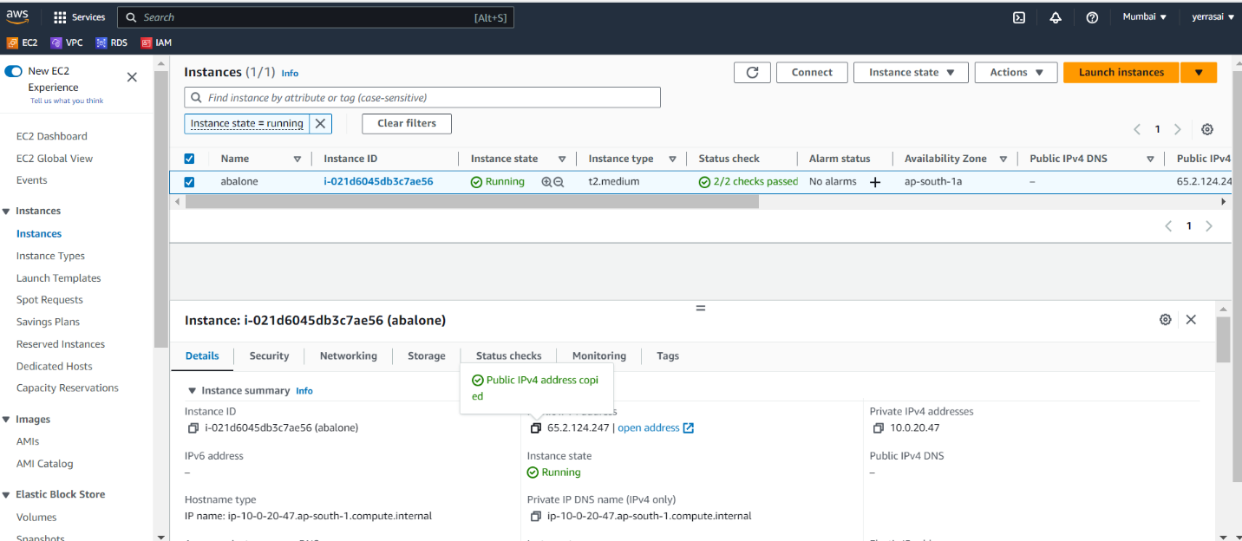

* Output :

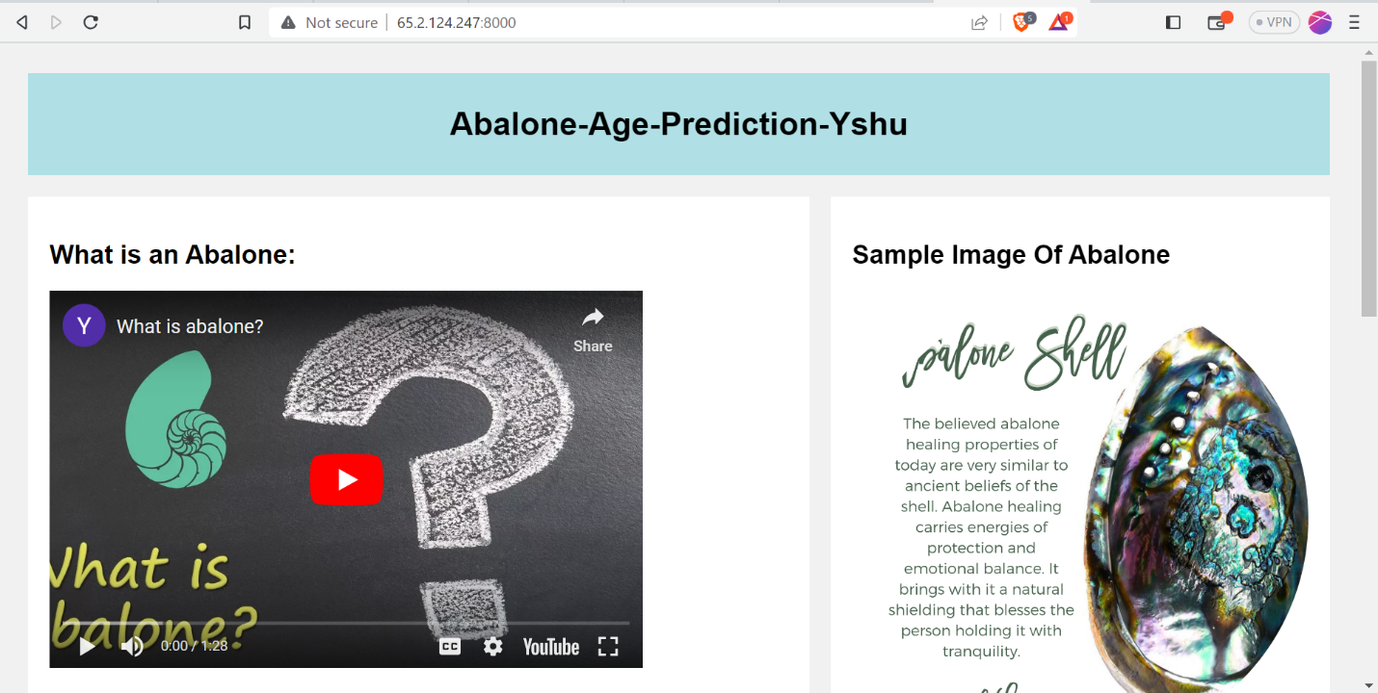

Procedure 2: Automation

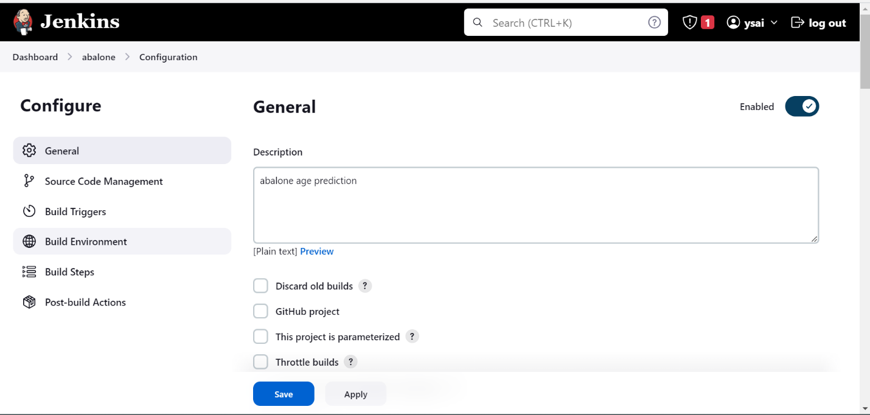  
Step-2 Now select git in source code management and give the url and credentials then go to build in steps and select execute shell and give the following commands.

* Sudo yum update -y
* Sudo yum install python3-pip -y
* pip3 install -r requirements.txt
* screen -m -d python3 app.py

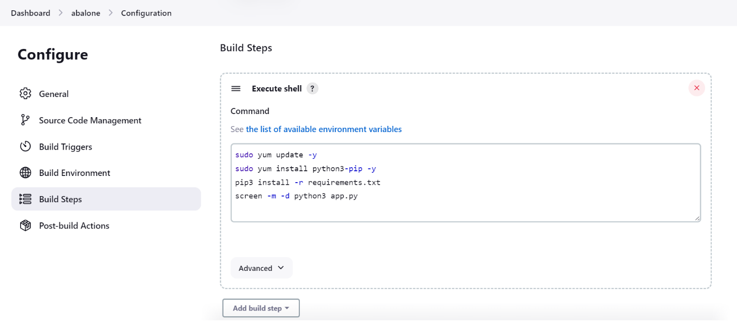

Step-3 Now build the job and check the output

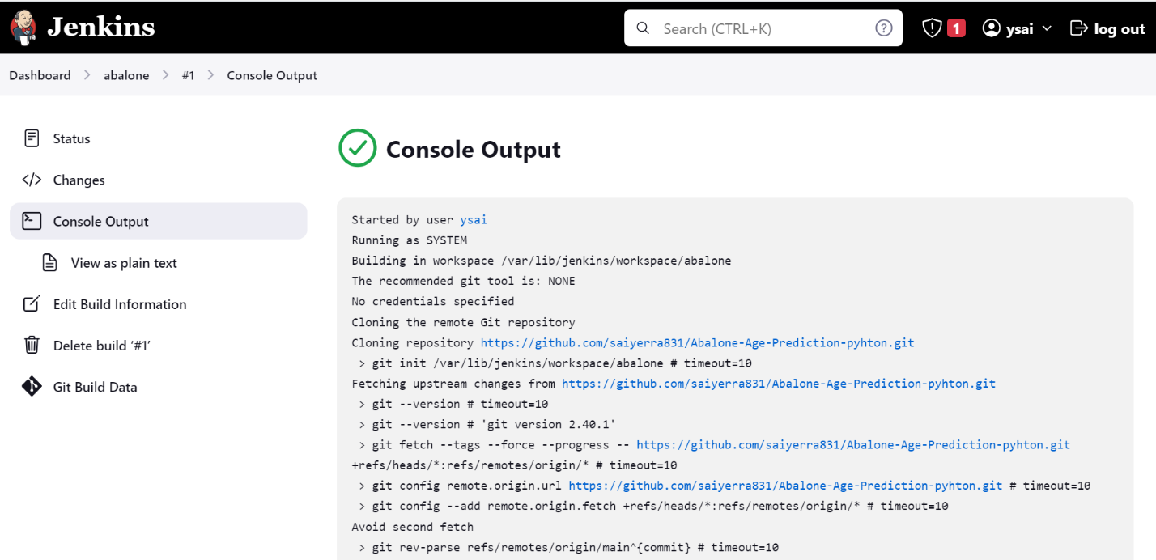

Step-4 Now browse the ip address and see if the website is running .



Procedure 3 : Building with terraform .

Step-1 Create all the required terraform files and push them into a private repository and clone the python code in user data file.

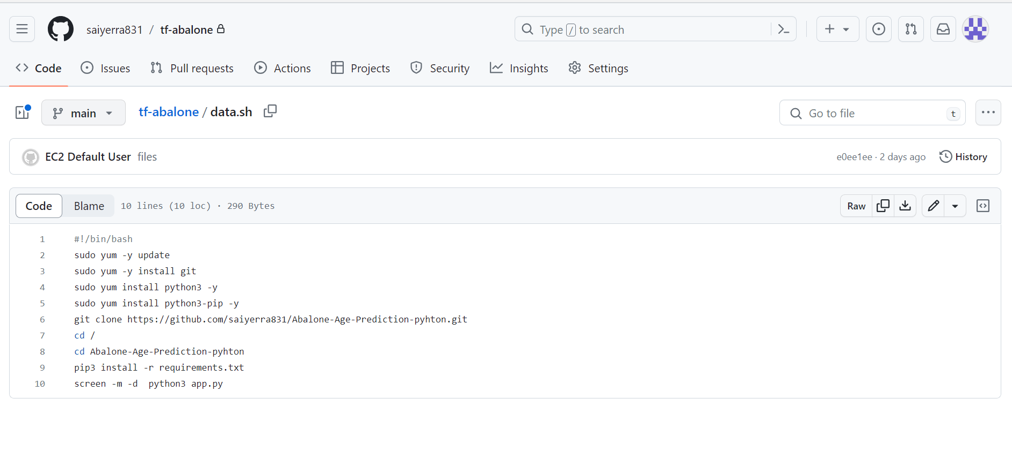

Step-2 Now create another private repository and clone terraform repository in it.

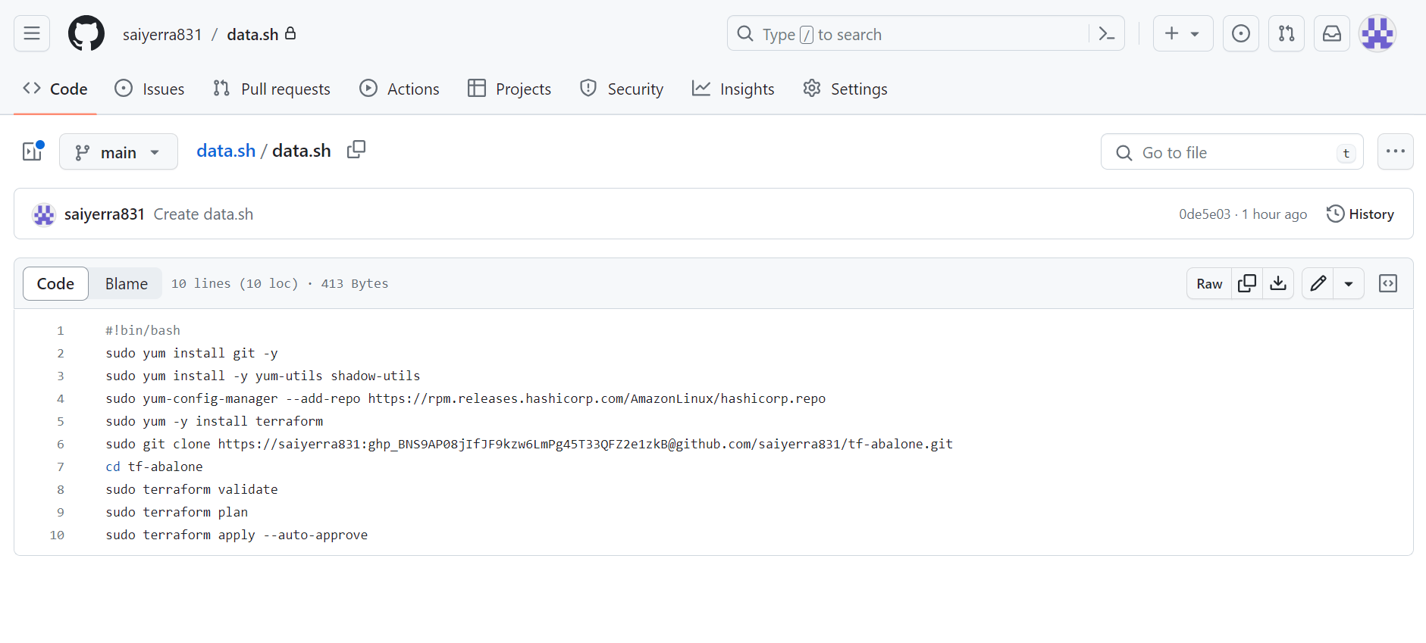

Step-3 Now select new item and create a free style project.

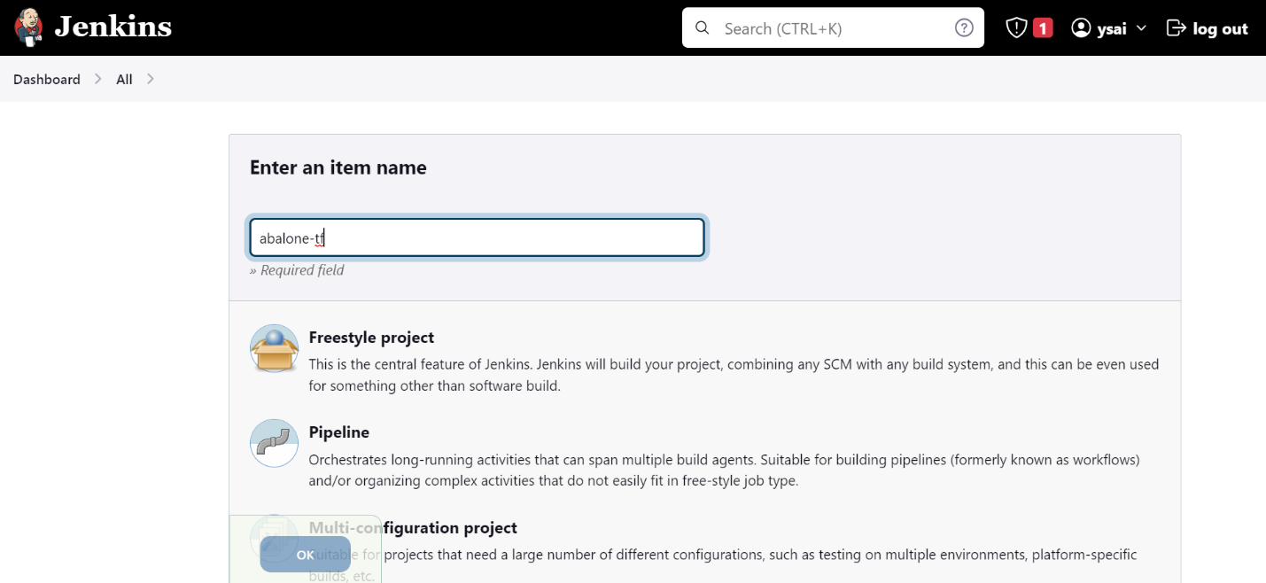

Step-4 Now select git in source code management and give the url and credentials then go to build in steps and select execute shell and give the following commands

* Sudo chmod +x ./data.sh
* ./data.sh

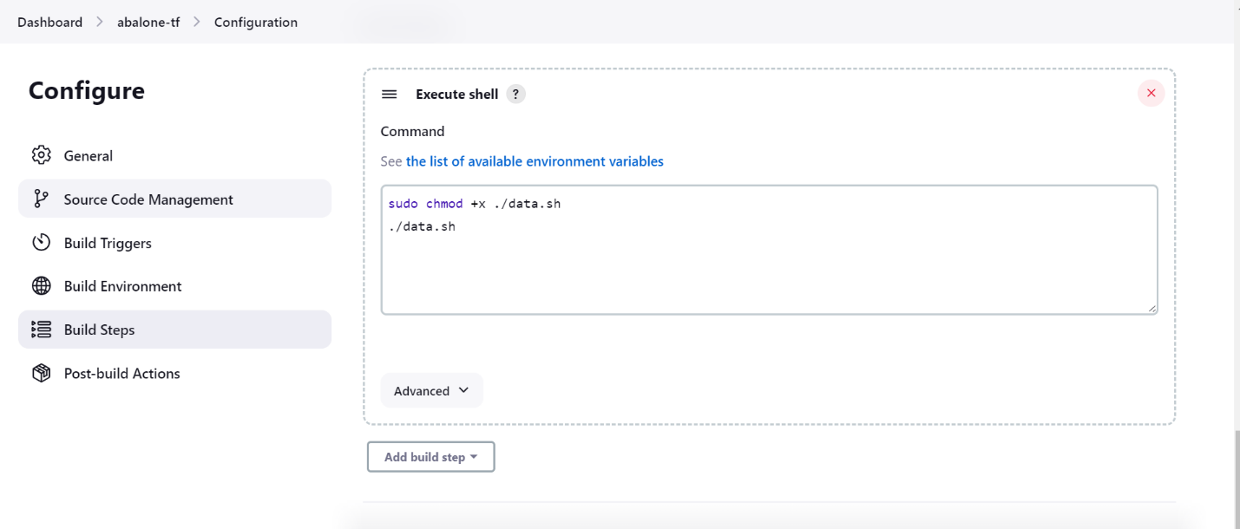

Step-5 Now build the project. After the build gets success go to aws console and copy the ip address of the instance which was created by terraform.

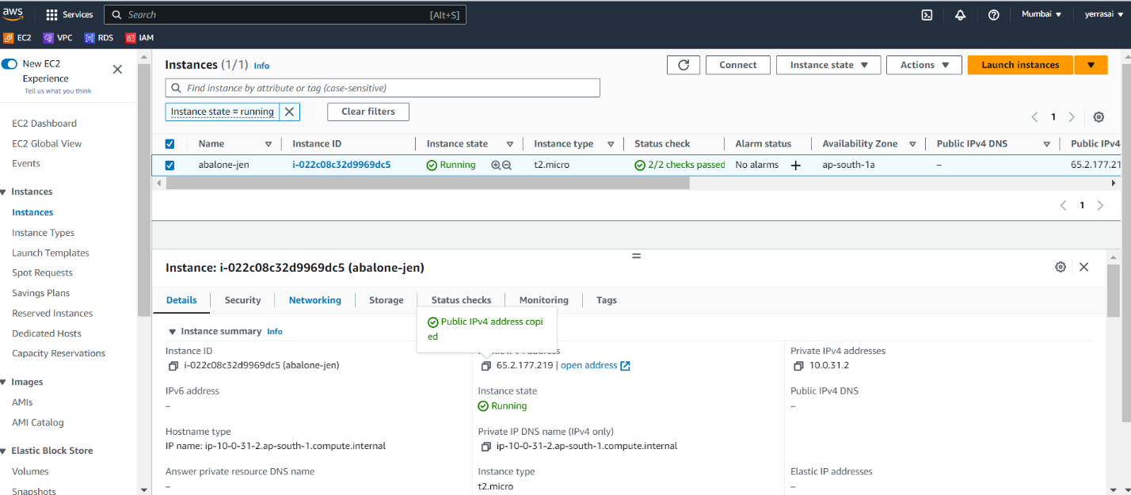

Step-6 Now this is the final output of the project.

